Hello,

The latest version of wireshark-setup-1.0.7 may have a bug as it can not play back RTP audio stream captured on laptop PC using Cisco IP Communicator.
The file [RTP streams] can be played back normally with the development version of wireshark-win32-1.1.3 or an older version of standard wireshark.

The same file [RTP streams] can NOT be played back with the latest standard version of wireshark-setup-1.0.7 currently on your website.

Just wondering if anyone had a similar experience?
I haven’t changed the default configuration of wireshark, compare the 2 screen shots.

Thanks
Oumar

Statistics
VoIP Calls

wireshark-win32-1.1.3 → YES
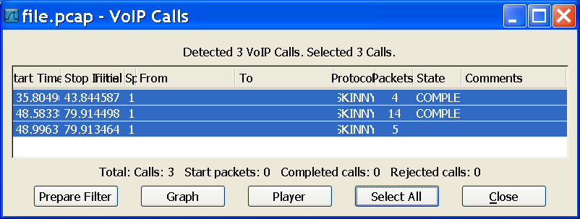

wireshark-setup-1.0.7 → NO
